

22, p. t;plltutl, Up2tu11mt1Jtug Lynn. 5, uhtl. 314, (PA, r. EpeBaH, lip. Apli1aKYHflTIÅa 5, ROM. 314)  phone: +374 95 260 113, +374 91 490 694, e-mail; management-consulting@mail.ru

20.04.2023p.

UP-012/01-23

 Ablltuppnúlþpþ Ifuupqþ hullfu1Jt1pþ llbllullltup Uhtupntl tutu»utnpJtut1þt1

2tupqbLþ ultupntl ftJtu»utnpJtut1,

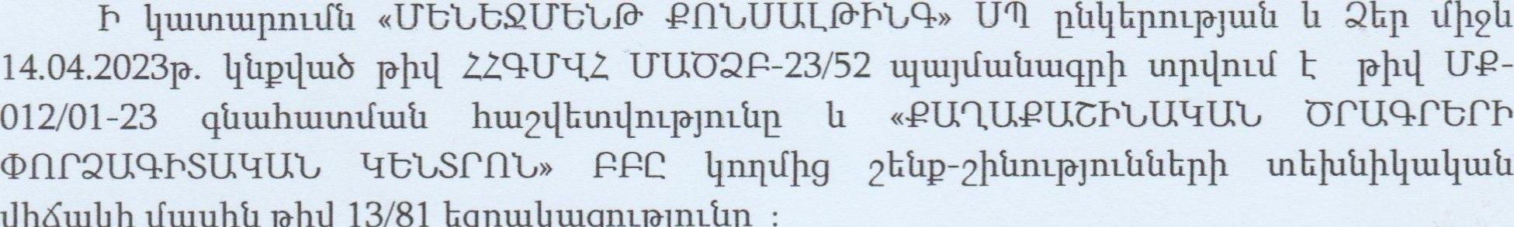

r

LlþKuu11þ

Iftuuþtl

pþll

13/81

bqptulltugnumnúlp

Unqþp pþll UP-012/01-23 qtltuhultnlftutl hu12Llhu111nL1ðJnLt1L1 11



2þtxnL1ðJnLt1t1bpþ tnblutlþlltulltutl Llþúullþ Iftuuþtl pþll

Ztupqtutlpnul,

tntlophtl

# Лгьичиъ

|  |  |  |  |  |  |  |  |
| --- | --- | --- | --- | --- | --- | --- | --- |
| qtnuhuu.nlln.ll qntjpb htnugk | | | | | | (липи 171ђр6 | |
| ЪКрЦшјшзф-иЬ фшитшрпрКр | | | | | | И4 Џ4шјшђш[1ф ијшшХЬ | У 14042023-05-0095,  14.04.202Зр. |
| qt1tuhuumftut1 итшгииипиђр | | | | | | 22, 9ЬчшррпЕђфрф zftupq, „ЪшьГшјђр Чшри&ђфи, qjnul    zupdbp п п пит | |
| qt1tuhunntftut1 ИчиппшЦ | | | | | | 11шьГшјђршјфђ tui12tupd qnzjph ошшрьГшђ  11 шиш | |
| qtnnhtuunlm•t bpunlnttlp | | | | | | (-ЈЬфшђшђтрјшЬфршфпђр | |
| SkIltuqt1tnftut1 unfutupbll | | | | | | 22.03.2023р. | |
| qtltuhunntftut1 unfutuplnl | | | | | | 22.03.2023р. | |
| 'Tlunn№punnnt | | | | | | 22 %7шрргпђфрф [ftupq, ЧшриЬђфић ћшИшјЬршчЬшшрш& | |
| qtnnhunmftut1 | | ш 1fu.1t1tu | |  |  | 22 U(JOQB-23/52 | |
| qt1tuhu.1 | (К КЬ | | ш hunftu ) | | | S шђ2п 11 и ШЬ 44-2022-38 | |
| qtnuhunnnq 1.ltuqtftullkpulntpjntt1 | | | | | | «иьььяиььгрпььтщрпьф) итс | |
| qtltu.hunnnll l.ltnqtfulllkpu.lntpjultl щ ш tnu htuu К | | | | | | ш | |
| qtnuhunnnq ЦифиЦКрчпгрјшћ фшитшф htuugk | | | | | | 22, р. Ьрђшђ, EIbi1tnpnil Цшрд. 2112., 314 иЬЬјш4 | |

41uuhtumnn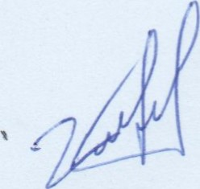 S -3пфшИфијшИ U2-012/01-23 1 29

## впчиьаистдавпдь

qtntlu 1. ЈоКршЬпгрјпгћ

1.1. bqpullltugnzpjnz& tupdbp11 ЏЬршрЬрјич qtntlu 2. Ctlllhtutmtp 1.nkqkuntpjntt1tlkp 11 hb1ft1tutltut1 rptjpt1kp



### 2.2.2шд/Ьшфпрјшђ Ьш/ишијшјьГшђђЬр [1 ишћьГшђшфш4пч 11/7171jpi1bp

2.3. 4ђшћшшьГшЬ шпшр4шђ ђЬр4шјшщ/ш& фшишшрпрЬрр

#### 2.4. 4ђшћшшьГшЬ шпшршпршђрд фшћшшЏппфршфиђшђ фшрЬрд

2.5. 4ЬшћшшИшЬ qnp&umnup, qiltuhunntfzutl Ьщшшшђ



2.8. qtltuhtutntlnn qnzph p&nzptuqhpp



4ђшћшшЏ1117 u1i12tupd qnzjph џпишђђшрђЬрр

Sb11tulltujnufptupu1bq17 [Ьпш

2.9. qtltuhtutntfulil 11шьГшппш Ьђшрищфрд,

24фршпЏшД zfnubgnztlbph 17фьГђшЏпрпиГд



3.1 Ош]иишјфђ lfnmbgnuf qtntlu 4. qtnuhunntftutl шпшгищршћрь шрдјпгћрћКр qpu111tutmtpjntt1 gtut111 ДИЧЬКЧИО

4lnuhtumnn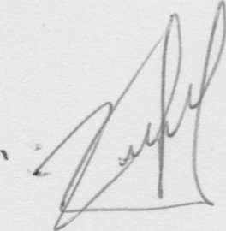S. -ЗпфшИИђијшИ И2-012/01-23 €2 2дИпшиЪИд 29

qznz/u 1. bbpzubnznnzû

### 1.1

enuUULfòÑ,q» Urn 11 22 q,hquuppnúlþpþ lfuupqþ hu11fu1Jt1pþ Ilhllullluup Uhuupntl tutužunnpjllltlþ lfþ211

lfuupq, ht111fu1Jt1p qJnL11 Lntuulllnúp 6 htuugbnutf quntltlnq tut12tupð qm-JPþ 211L11u1Ju111tut1 tupðbpþ qtltuhtutntftutl u121ututnu1t1pt1bp:



zutezupdqnzjpþ oznzupzfzutl hzuzfzup :



tupmnúptlbpþ hu11fu1åu1Jt1bgnL1fp hþlfp btl tnulthu bqpu111u1gt1bL11L, np 22, qblltuppnúlþpþ Lfuupq, hi111fu1Jt1p qJnL11 Lnuuulhnúp 6 hl-uughnuf quntlllnq ult12tupð qnypþ 211L11u1Ju111tut1 tun 20.04.2023p., Iltuqtfnuf

21.100.000 ( putlltllfbll tfþthntl lfbll htupJntp hl.nqup ) 22 Ilptlllf qt1tuhu1tnnL1fp Iltlltnulptlbl qtlulhtlltntfultl qnpbnutlbntpjnutl þptulltutltugtlnrl unupJb11tn-

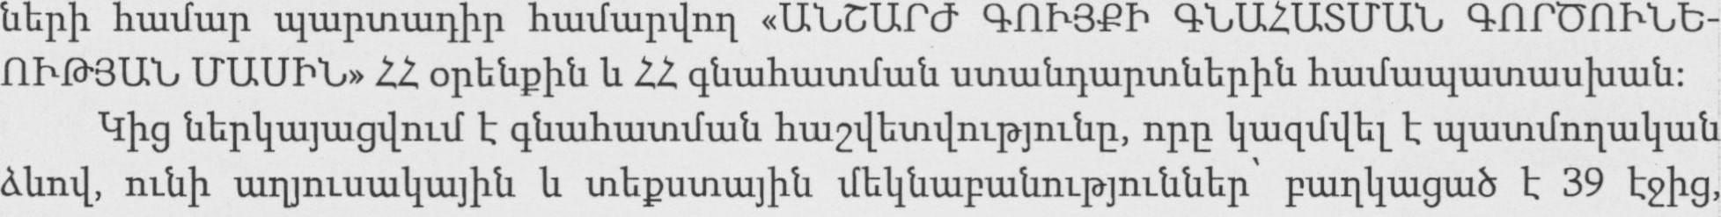

tlhpuunJu1L hunlbL11u18p:



hu11fu1åu1Jt1:

quuthuttnntz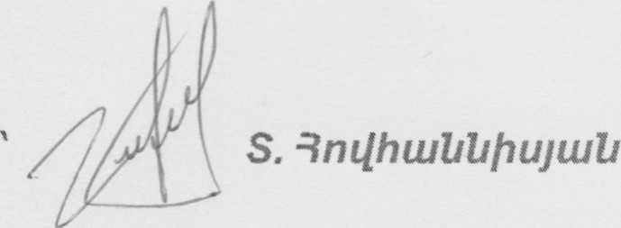 112-012/01-23 

q11211u 2. Cål)hzuånzp znbllbþnzpjnzåtlbp 11 hþzfåzulltutl 4pnzjpåbp

#### 2,1. qtlulhtutnnrlþ Ilhtlutuqpnupjnúl 11 tut1Uu11unL1ðJnLt1

|  |  |
| --- | --- |
| qtlulhunnnnþ tutlnúl, tuqqu1t1nLt1 | Sþqptutl «ntlhcutltlþujtutl |
| qtlulhunnnrlþ tllltujulllultlþ hullflllp | q q-2022-38 |

lfunnnzgblþu, Iltuqlfbllld IJ11LJå hu12dbzntþ1L1ùJ11Låp, lü121t12ån11Ï)1/nL1f opbåuopnzpjulåp 11 «IIå2tupd qnypþ qtzzuhlülfllfluå qnpðnzåbnžlù]lüå lftuuþå» 22 qtlluhtuznzftuíl uznzuålltupznåbpþ opnypåbpþtl Illillflutqtuzntuu/utuå:

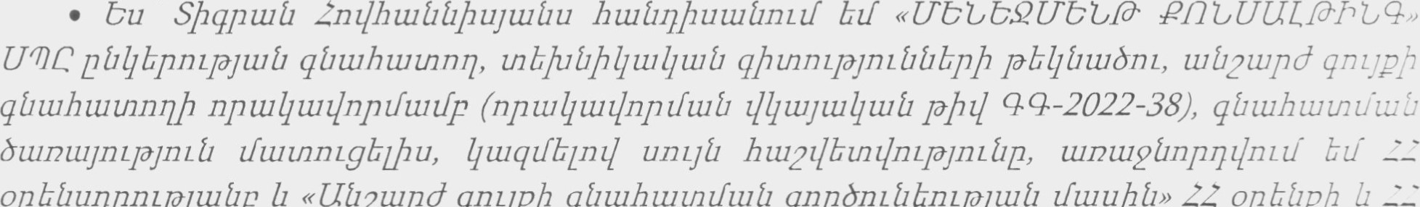

bu

11

• 2111í11Ìþuu1åu11T111 unž]íl qíllühunnnz¿fp Ihpwl]tuíltugånll ultlâ qnzyplžl//£'

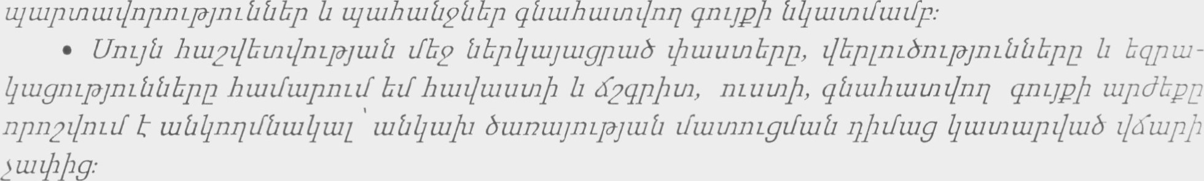





tlbp11ü1Jtugt1btnu Ilblllpnutf qtltuhultntfultl qnp8wnnLjpþt1 hultfllltllültnultlluultl.

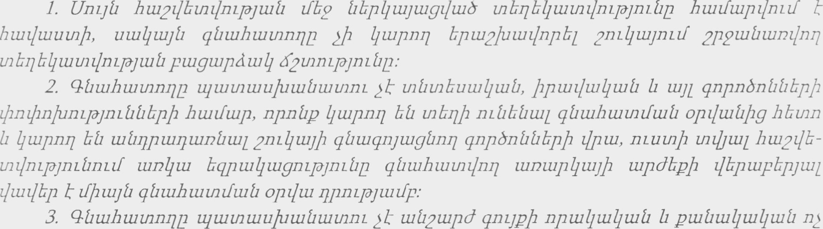

h

älll&wnnz jnzpulhultnånzpjnztlûbpþ hunftup.•

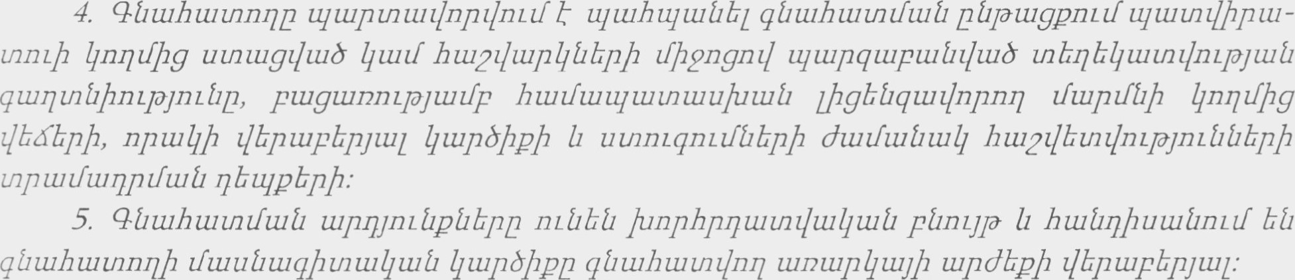

29



-012/01-23

6. qtzzuhzuznnqp zyzuznzuuluzuåuzznzlnzpjnúl 4pnzzf znbqzuqååzfulå dunfulåzull qåzuhzuznzftuå uzprynzåpåbpþ zlpuz, 11 ultupzntuz/npz/zuðžt zlbppþååbpupuzgtuhuyznbznz.•



åzuluzuznbuzþuð t qtltuhzuznzfulíl zquyzfzuûzuqpnzl.•



UntJt1 ht11211btntlntpju1t1 qtlulhultntftutl tuntuplltutl hultlllþuultlntlf 22, %ntuppnLt1þpþ Ifuupq, hullfu1Jt1p qjnuq LnLutu11nLt1p 6 htuughnuf quntlllnq tut12tupð qnypp•. 

¶lunntlþpunnnuþ llnntfþg t1bp11u1Jg11bL btl ult12tupð qnypþ tllltutntfullfp þpulllnúptlbpþ

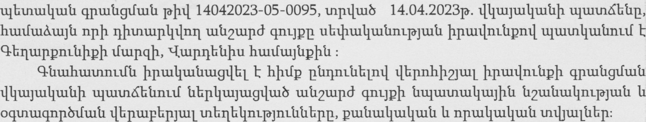

Ut12tupð qnypbpþ ubiþu111t11t1m-1ðJü1t1 (oqtnmqnp8tfu1t1) þpultlnúpþ qpultl¶fllltl

«euuueucn,uuuu oruqrbrh onrauqhsuuuu þpullltutltugtlbl 11 19.04.2023p unpullftunptlbl pþtl 13/81 bqptu11tugnL1ðJnLüux qtllltuppnutlþpþ

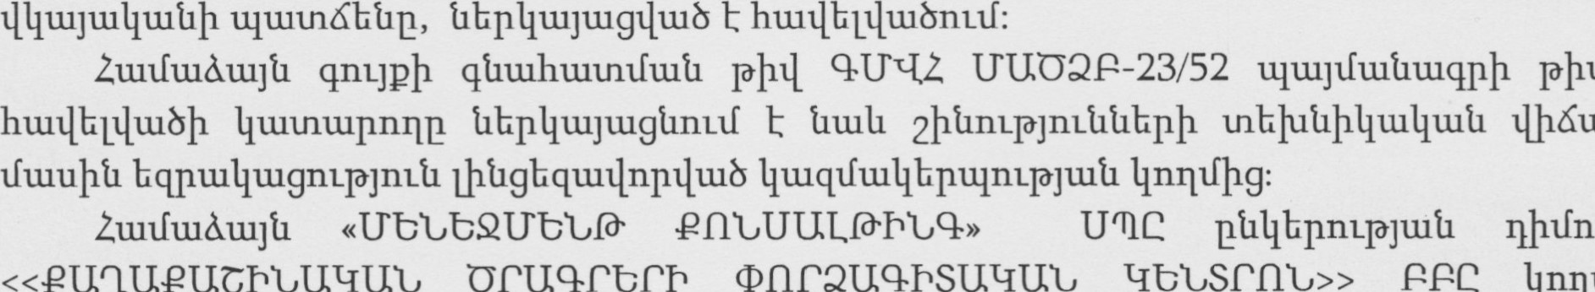

llþúullþ

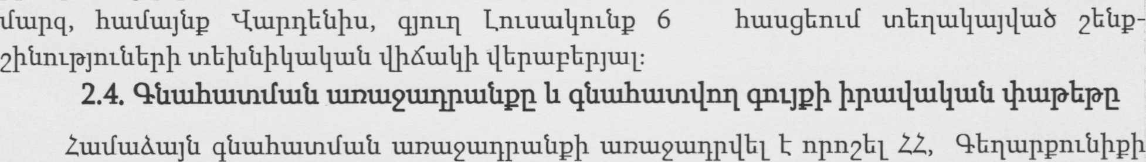

tfuupq, ht11tft11Jt1p X-Itupllbtlþu, qJnLt1 Lntutullnttlp 6 htuugbnttf qtntltlnrl tut12tupð qnypþ

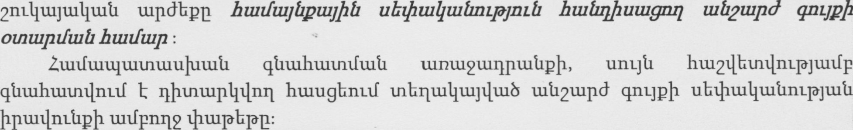

##### 2.5. qtltuhtutntfultl qnpbtunnup 11 tltllu.ltnull.l

Unuti qtltllhultnm-lftl þpu111t11t1t11¶lbL Abnmppnúlþpþ Iftupq, htL1tfu1Jt1p X-ItLIN1bt1þu, qjnuq Lnuuuullnúp 6 htuugbnutf qtntltlntl htütfuyåpzujþtl ubzþzulltuûnzpjnzå htutülþutuglll zuQuzpdqnqpþ oznzupzfulû hzuzfzup :

UnLJt1 hu1211hu111nL1ðJuut1 Ifh2 «2nLllu1Juu11tut1 tupðhp» htuu11tugnqnL1ðJnLt1p Ifblltluuptutlllnuf  hbtn11Ju1L llbpul. Cnz¼uytülltüå updbpp huezlzupåuyþå qpuzzfzulltuå zfbbnzpjnzå k, npnzl huzzlzuûzuptup 4þptü4zuåzugzlbp, qåuzhtutntftuå zuzfuuzpzåh lžpnzpjtutfp, 2tuhwqpqþn 4nqzfbpþ

llnqtfbpþg jnzptuptüåyntpp, þptuqb4tltub l]låbzntl, qnp&nzzf nt12tutfznnpbå 11 uzntüåg huzplßülffltuûpþ.•

Olltuhwtnnn ' 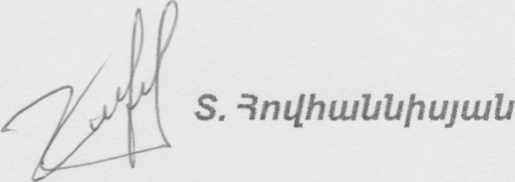 lure-012/01-23 

«2u12z/zup4u1Jþå Ilptuzfuzlltutl zfbðnzpjnzå»-p zlbpzupbpnzzf opzuzfzu4zuå qåþå, npp t zlõzupzlbl opJb4znþ htuzfzup zunlzznpzujþå 211L4u1Jtu11tuå qnpðzuppþ dzuzfzuåzull.•

opjblltnþ tupdbpp huzållþuzuånzzf t båpulllpjull qåzuhzuznzlzuð zupdbp, pb Illüå/unpnpþuð 4zuzf zlzudzunpþ þpullltuå qþå:

«...2zuhzuqpqþn 111211Lfbpþ zfþ2b...» zupznulhuyznnzpjnzûp zlbpzupbpnzzf 21ühzuqpqþn qånpqþå Iz zluzúunmthå.•

«...pzug b tfpgu14guyþå 211L11tujnzzf qåtuhtuznzþlll 0Ðb4znþ zþnIuzuåzu4nzzf...» t12zuåzu4nzzf



«...11 zunzuåg htup4zuqpu1åpþ...» í12zuåtu11Ï7L1ft, np 1117111fbpþgjnzpzuptuåynzpå Ï7Låþ qnpðzuppþ þpzul/tuåtuglfulå qpqz.uzqtuznúunåbp, ptujg 1112111fbpþg 11 zfb4p hzup4zuqpzIzuð 11ZZ11f uznþzqzlzuðék qnpðzupp 4zuznuzpb1.•

«ùnzlluyuzlltuå zupdbp» huzu4uzgnzpjnzåp båpzuqpnzzft, np qåbpp uzuhzfzuûllnz¿f båpuzg 11 zfpgnzåzu11217L4uynzzf, npznbÏ1 zfzuuåu14þgûbpí1 odznzþüð bå qnpðb1Ï7L zuqwznnzpjzuzfp.• ù11L4uyzu4uzå tupdbpp hzuåqbu qullþu npzqbu zunuzzlbl hzuzþuåzulltuå qþå, npp, puzn

opnzpjzuzfp 212L4uyu111tuå zupdbpþ utuhlfzuåzfzuå zfb2 blltuð zquyzfultlåbpþå hbzn11b111L 71bzqpnL1f:

2.6. 1.121ututnu1t.tpt1hpþ hu-ltnuptfu.ltl unfuullùllbpp

qtltuhmtntftlltl 11121ut11tnü1t1pt1bpp Iltutntuptlbl btl 14.04.2023 p. tfþtlžll 20.04.2023p.:

Sbquqtltltftutl ultfutupþlltl 14.04.2023 p.:

Ortliuhuuuntfuutl ultfuuupþlltl 14.04.2023 p.:

##### 2.7. qtlu.lhtumtfuúl q.npbptllðtngp



1þnLLbpþg.

* åzuþltutqzuznpuzuznzullzuíl zþ11L1
* hþzfåzu4u1å zþnL1

LI-uluultllt.utnptuutntulll-utl 1þ.nLL11Ltf þpullltutnngtlnutf tu) qtlulhuutntlnq opJb11tnþ tþtuutntupnpbpþ hultluupuuqpntlf 11 munttftltuuþpntmnutl,



2þtft11-u11u1t1 tþntlntlf þptulltutltugtlnttf tu. qtltuhtutntlnq opjblltnþ tnbqtuqtltlntlf (Inuutlltllltllpnutf) (Iltulutltu8 qtltllhunntlnrl opJh11tnþ tnbutullþg),

p. qtltuhuutnlfultl hullfuup tut1hpu1ðb2tn unbilb11uutmlnL1ðJtut1 htutluuptuqpnuf, lf2uu11nL1f 11

Ilh11L11LbnL1ðjnLt1,

#### quulhwtnmz S. (je-012/01-23 t2 aliqu1LTbba

q. qt1№uhtuunftut1 htutftuuwuunuulututl uhqpnttlptlkptl, tfnmkgnuftlkpb №fhpnlltlkpb ptnnpntpjnttl,

П. qtltulnumnuf' Etnnpqtu8 №fnmkgtftutl (ЧипГ №fnmkgnuft1kpb) ЧЬрштГипГр,

К. №lkp2t1tutltut1 шрдјпгћрЬ h№12qvup111ftut1 ичшшшЧп4 ипиррКр 1fnmkgnuft1kpnq №upnjnttlptlkpb htutftunpnuf,

q. hU124kmqntpjtut1 №ltuqtfnuf 11 итрш№ГшдрпиГ:

2.8. qtltuhunnqnq tut121.upd q.ntjpkpb ptmtptuqpkpp

 28.1. иьсиго'

##### ИШПЕИШЦ N 2.8.1

|  |  |  |  |  |  |
| --- | --- | --- | --- | --- | --- |
| 2zuugb | 22, 4ЬпшрртЬфрф tfuwq, ]пијшјђр ЧшрчЬђфи, qJ11LIl  (тишђтђр 6 | | | | |
| 2пашьГшиф Ьчшшшђшјфђ фшђшђтрјтђ | ИрштђшрЬртрјшђ, pt111bppoqmzuqnp&tftui1 шл шртищршђшђ шђш4трјшђ | | | | |
| 2пчшьГшиф рр&шпђшђшђ ђдиЬш4трјтЬ | ¶тчшшђшЬиш4шђ шршширш4шђ орјЬђшђЬрф | | | | |
| Чичшишршјћђ | 05-043-0104-0002 | | | | |
| 2паинПииф ИшђЬрЬид /Ћш/ | 400893 | | | | |
| бфђтрјтђђЬрф ьГшђЬрЬир /pU | ЧшруиђшЬ 2ЬЬр | | | 316,1 | |
| Тш}1Ьиш | | | 354,1 | |
|  | | | 210,0 | |
| Тш]1Ьиш | | | 28,3 | |
| .Qp шиищшђ | | | 136,2 | |
| '7)tuhbum/.Qpunltuqtui1 | | | 87,4 | |
| Тш}1Ьиш | | | 66,6 | |
| ТшЋЬиш | | | 106,7 | |
| Тшрфи | | | 160,3 | |
| тшрћищ | | |  | |
| 12Ьђпчајп[ђ / Чшрьшђшђ 2Ьђр / | | | | | |
| 2шрђшјђтрјтђ/2шрђ | ьГЬђ ilbpqtiiI1i1Jtu | | | | |
| бЬЬрф шЬишђд | Аир Ь | | | | |
| Ош&ђЬрф шЬишђЕ |  | | | | |
| ЬЬррфђршрфтрјтђд /if/ |  | | | | |
| 6htmzpju.1f1 4шппщьГшЬ шшр&рфф | 1989р. | | | | |
| Чпйт&фђшфшЬЬр |  | .Qmp | qzuq. |  |  |
|  |  |  |  |  |
|  | (шђршЏпр/ ширп11ЬрДшршрЬ фи]пиђшђђЬр | | | | |
| ишашииршјфЬ | 05-043-0104-0002-001 | | | | |
| ЬЬррфђ Ашншршђрд (0-7) | 1 шђршЏшршр | | | | |

#### 4ИшТиьппп' S ЗпфшИЬђијшИ [ГР-012/01-23 дипшиьид

|  |  |
| --- | --- |
| бЬЬрф шфђфђшђшђ фТшђ (-4,4) | -3 шђршфиршр tui12tupdqnup11 рђшђшДпђ [1 tuu]tuhntlb111L hunfuw tui1hptudb2lI1 4шшшрЬ1 mdb17tugtftui1 [1  Ь ш ша ЬьГшђ ш шшшђрђЬ |
| Ununph аптд | ФишлЬ |
| ЬЬррфЬ ипЬЬрд | Фишл Ь |
| ТшшпйшЬЬЬрф 02шђшђЬЬрд | фшјшЬ |
| • (ЈшЫшЬшфшђпиЉЬр, ьпЦЬ4трјтђђЬр | бфђтрјшђ Ирш шпђш bi1 рищьГшрфЏ hnphqninul]tuil |
| 22ђђпчајтђ / ¶tuhhum/ | |
| 2шрђшјђтрјтђ/2шрђ |  |
| бЬђрф ьпЬишђЕ |  |
| Ош&ђЬрћ шЬишђд |  |
| ЬЬррфђршрДртрјтЬЕ /U | 7.4 |
| бфђтрјшђ ђшпп@шђ шшрффф | 1989 |
|  | (ш@шЏпр/ширп11ЬрашршрЬ фићшЬшђЬЬр |
| ЬЬррфђ huzpazuptu&pp (0-7) |  |
| Ишишиьпршјфђ | 05-043-0104-0002-002 |
| бЬЬрф шЬДф4чиђшђ фХшђ (-4,4) | -3 шђршфиршр tui12tupd чпчрфрђшфшђпђ шђЏшш[щ guhzuqnp&nufp tuu]tuhndtil11L 1гшьГшр tui1hptudb2lf1 4штшрЬ[ mdhIltugtfu1i1 [1  4bptulltubqinftui1 ш»ишшшђрђЬр |
| З 2ђПпчариђ / ¶uthhum/ | |
| 2шрђшјђтрјтЬ/2шрђ |  |
| бЬђрф шЬишђр | Ур |
| Ош&ђЬрф ьпЬишђд |  |
| ЬЬррфђршрфтрјтђр ,/lf/ | 7.4 |
| бфђтрјшђ 4шпп@шЬ шшрффф | 1989 |
|  |  |
| ЬЬррД1 Ашншршђрд (0-7) | ОфршђшђчЏшД>К |
| Ишишииршјфђ Дш&ђшфр | 05-043-0104-0002-003 |
| бЬђрф шЬД1фђш4шЬ фХш4 (-4,4) | -3 шђршфиршр tui12tupd qnyph рЬшђшЬпЬ zuu]tuhnlb111L 1ЪшьГшр tui1hptudb2tn ђшшшрђ mdbIltugtfu1i1 [1 |

#### S ЗпфшИИђијшИ ИР-012/01-23

|  |  |
| --- | --- |
|  | ЏЬршђшђДчГшЬ ир]ишшшђрђЬр |
| Phll 42Ьђпчајп[И / '¶tuhhum/ | |
| 2шрђшјђтрјтђ/2шрђ | 1/1 |
| бЬЬрф шЬишђд | Ур |
| Ош&ђЬрф шЬиш4Е |  |
| ЬЬррфђршрфтрјтђд ,4f/ |  |
| бфђтрјшђ ђшпд@шЬ ишрЬрфф | 1989 |
|  | ( шЬушЏпр/ ширп11ЬрДшршрЬ Џш1тшђш4'ђЬр |
| ЬЬррфђ ћшншршђрд (0-7) | Офрш4шђищЏшД>К |
| Чищшишршјфђ | 05-043-0104-0002-004 |
| бЬЬрф шЬДфђшђшђ фТш4 (-4,4) | -2  Ьђршђш impnqtftuil т ilbpu1Qzui1qi1tftui1 |
| 52ђ[пирјп[ђ / 9ршЦищшђ/ | |
| 2шрђшјЬтрјтЬ/2шрђ |  |
| бЬђрф ьтЬишђд |  |
| Ош&ђЬрф иЬишђЕ |  |
| ЬЬррфђ | 2.6 |
| бфђтрјшђ 4ummgzfzut1 ишрЬрфф | 1989 |
|  |  |
| ЬЬррфђ ћшришршђрр (0-7) | Офршђшђищч1шД>ђ |
| Ишашиьпршјфђ | 05-043-0104-0002-005 |
| бЬЬрф ьтЬД1фђшђшЬ ф[шђ (-4,4) | -3 шЬршЏшршр |
| Plul 6 2ДпирјтиИ / Тийђит/2ршЦищшИ/ | |
| 2шрђшјђтрјтЬ/2шрђ |  |
| бЬђрћ иЬишђд | Ь/р |
| Ош&ђЬрф шЬишђЕ |  |
| ЬЬррфђршрфпрјтђд /Ш | 2.9 |
| 61htmzptut1 4umnzgzft11t1 ишрффф | 1989 |
|  |  |

qlnutuumnn '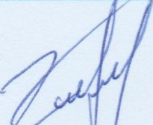 S, -ЗпЦ"шИЬђијшИ И2-012/01-23 дИпшьГЬИд

|  |  |
| --- | --- |
| ЬЬррфђ Ашншршђрд (0-7) |  |
| Ишишишршјфђ Дш&ђшфр | 05-043-0104-0002-006 |
| бЬђрф ьпЬ1иђфђшђшЬ ф&шђ (-4,4) | -3 шђршЦшршр r-Itunmjgi1bp]1 рђшђшђпђ [1 шђЏшшђршЋищпрДпиГр tuultuhnlbl11L hunftup [ЧЬшр ђшшшрЬ! 11]1i11i1g чшш&рф 16шшш4ф mdbwugnufp Ь/р-пЏ: |
| Plul 72ђђпчајп[ђ / rqtuhhum/ | |
| 2шрђшјДтрјтЬ/2шрђ | 1/1 |
| бЬДрф шЬишђЕ |  |
| Ош&4Ьрф ьпЬиш4Е |  |
| ЬЬррфЬршрартрјтђд /zf/ | 4.6 |
| бфђтрјшђ 4umnzgzfzut1 ишрЬрфф | 1989 |
|  | (шђушЏпр/ ширпЋЬрДшршрЬ фимЪшђш4ДЬр |
| ЬЬррфђ Линшршђрд (0-7) |  |
| ИшишиьпршјфЬ Дш&ђшфр | 05-043-0104-0002-007 |
| бЬђрф шЬДфђшђшђ ф&шђ (-4,4) | -3 шђршЦшршр tut12tupd qmph рђшђшђпђ tuilltnzn&q 2tuhmqnp&nufp tuultuhnzlbl11L 1ЪипГшр tuilhptudh2tn ђшшшрђ mdbwugtftuil  ЏЬршђшђђьГшђ 1112]ишшшђрђЬр |
| 82ђђпчајгиђ / muhhum/ | |
| 2шрђшјђтрјтЬ/2шр4 |  |
| СЬђрф ьтЬишђд | Ур |
| Ош&ђЬрф шЬишђЕ |  |
| ЬЬррфђршрартрјтЬд | 3.4-3.9 |
| бфђтрјшђ 4umnzgfu1t1 ишрЬрфф | 1989 |
|  | (шђршЏпр/ ширп11ЬрДшршрЬ фићшђшђђЬр |
| ЬЬррфђ htuprjzupzu&pp (0-7) | Офршђшђи19Џш&2К |
| Чищшиьтршјфђ | 05-043-01040002-008 |
| бЬЬрћ ьпЬД1фђшђшД' фХшђ (-4,4) | -3 шђршЏшршр  unqtuhmlti111L 16шьГшр tuilhptudli2tn 4шшшрЬ[ 17Ldb17tugzfu1i1 llhpti1lltui1qi11fti1i1 1112]ишшшђрђЬр |
| РЬЦ9 ЧшппщфиДр/ яшриђищ/ | |
| ЧичшитршјфЬ | 05-043-0104-0002-009 |

#### 4Иш"шитпп' S ЗпфшИИђијшИ (Е-012/01-23

|  |  |
| --- | --- |
| DZUtIZU1 | 320,61u.li. |
| Plul IO Iltunmg11utčp/'Pułpuhutq/ | |
| tluzłyuuznpuzj2t1 bzublłułqhp | 05-043-0104-0002-010 |
| Dzuzluzz | 4,81 lu.ti. |

qtłzuhznznrlną qnyp12 łnzuuztzlłułptzłpp

CONSULTifiG"

12 n 3 i 734

### ąlltuhtuułnrł S. antlhwlll.lfiujulll t2fig

Qbuhuunnn S. 3n11hutbbþLIJtu11 IJ2-042/ÒÈ23• 12 LilJ1)uJ1fb11L7 29 t2þg

2023FLSUVLHJ

### Qbuhu.ltnnn' S. -3nt1hwUUþLlJtub UP-012/01-23 13 nbnullfbba 29 t2þg

2023FLSUVLHJ

Iltezupdqnypłh znb11ŁulłuynLLTt1b Iltujułgllułb uznnpll

Hoean KapTa , Oő03HaqeHbfg9 7771?????

3;łecs

2.9. qtltuhułuúutl úmntňgnLtft1Łp11 hun.fułnm-n tllłułpułqbpp, žllbpułnqułb hbútłułqnpnŁúĚ

qtlłuhunnłfłutl hliiftltulltutl Ifnuaťtgnnftlhptl hunfťttfułunulltutl Ifnunhgnuf, hlłułufunu1Jbt1 Ifnunhgnuf, bulluutujbt-l IfmnŁgnL1f:

qtlłuhułtnúllltl únŁnŁgnL1ft1Łplłg JIILpułpuutłynŁpp t1ŁpułnnL1f útutłpulúułutl tlbplltujułgtlułb Illłpułntfultl untupplłp Ifhpmłtlhp,

hułpúułp tfhpnłl lłnt11łpŁtn htutłqtutfultłptlhpnttf: UhlltłnLJt1 tfŁpmłp htłułptutlnp pułgułp&uł-

npn211nLŁf htl uulhufultlllułb ułpďhpll ułhuułlłp 11 t1U11UU111PJUILP,

p. qt1Łuhułu11fŁut1 htłułpunlnp ŁfnŁnŁgnnft1Łp11 11 IfŁpn11t1Łpla hunfhlfunnvupułp nLďŁ11 11 pntJL lłnąúŁpp,

unli11Ł11tuumlmpJŁut1 ułn11t11JnLpjnLt1.• qtłznhułznnqil&ptl qtlłuhułznlflütl hullTułp LULZIPUIU1ąP1/U1b oqłnzuqnpb&l n b hunn zu bu b bułhuł ti nül ITb Ö znnz ulti 11

### ąlłwhłułnntl

hnzuuı nzuıntıh n tıuıhuıznzfuıtı um ül uıfr Quıznuıpzfuıtı ı]ızuuznhpfr nz zquıızfuıfrlıhpp•.

Znquıüuıulı 211L11ü1Juılıuıü uıpdfrpp hlıüüuılıuıfrnuf npn211nLÜ hhın11Jü11 Ünınhgntlffrhpnıl. 1) huıüfrüuıınuılıuıü ünınhgnıünıl,

2) hnquıÜuıu11 ütıuıgnpllül]lıü uıpdbplı hü1211uıp11üuıü ühpnqnıl, 3) hllü11fü1ü1JfrÜ ünuıhgnuünıl,

4) ünpüuıınhıl-hpuııluılıuıü uılltnhpnıl uuıhüuıüılu18 qnpbnq ühpnqhlıuıühplı llhpuınüuıüp:

Zuıühüuımuılıuıü ümnkgüuıÜ llhpuınüuıü qfruıpmü uıpdfrpp npn211nLü k qüuıhuımılnq opjhlıınp tıntJüuılıuıü lıuıü huıüuıııphl_lı (üüuıüuıuıhuı) 0FJfrlııntıkph hkın huıühüuımfrınıl, npnüg huıüuıp uınlıuı k qühph ılhpuıpkmuıı ınkqhlıuıınılnıpjnıü•.

Zuıühüuıınuılıuıü ünınkgnı-üp ülkınp k llhpuınılh 11 qquıth 112hn mühüuı hhın11Jü1L huıüquıüuıüpükpntıf

111. qüuıhuıınqnq opJblıınp ünuıuılıuı duıüuıüuılıuıhuıımluıbnuf ılu16uınılhL k qnpbuıpph uıpmntüpntü,

p. qfruıhuıtnılnq opJfrlıınp lıuıü huıüuıqpfrlfr op]blıınühpü uılıınhılnpbü 2112111üuımlntü (tunu12uıplıılntü bü) 211Llıuıjntü,



0FJ17111nübpfr hbın lıuıuııluıb:

Uhuıduıüuıüuıll, lıpp puııluıpuıpılnuf ilhpnü2Jü1L ülü1Jüuıüühpp, uınnplı Üfrpllü1JuıgılnLÜ hü ülJü l_puıgnıgll'z ülü1Jüuıüühpp, npnüg qhuıpnuÜ hüuıpuıılnp k llhpuınbl huıüfrüuıınuılıuıü ünınfrgnufp h ınuıı qquıı_h 112hn.

tu. qnpbuıppühp, npnüp ılhpuıphpmü hü qtıuıhuıınılnq 0FJhlıınl-ıfr lıuıü huıüuıqphllı



uılıınlıılntpjuıü üuılıuıpquıllühpp,

1. huıühüuıınılnq 0FJhlıınp lıuıü tıüuıüuıınfruı 0FJhlıınühpp qu16uınılnLÜ hü hpuıuıuıpu111ü1JhÜ, puyg ni uılıınhılnphü,
2. 2TILllü1Juılıuıfr qnpbuıppübph üuıuhü ınbqfrlıuıınılntmntüp huıuuıtıhllı k, puyg huııfuıııphl_h opjhlııntıhpp qquıı_h ınuıpphpntmnttıtıhp mühü qüuıhuımılnq 0FJhlıınfrg, uıuıhuıfryntlf k untp]blıınlııl 62qpınmüfrhp,

q. llhpybpu hpuılıuıfruıgıluıb qnpbuıppfrhplı üuıulıü ınhqblıuımılntpjnı-üü hpuıınhuuılıuıü

 (uyulıÜpÜ, ınbqblıuıınılnımuıü puıguılıuynımnutı, ubübpqhınhll qünpq, 211Lllü1JuılıuıÜ uıuıjüuıüübpnuf llüpıluıb qnpbuıpp, luüqpuıhuıpnı-yg 11uıKuınp 11 ülJ1ü),

h. 0FJhlıınlı uıpdhplı ılpuı uıqqnq lıuıphnp qnpbnü k huıüllfruuıünuıf 111Jü (Ilıtıp, npp



lıuıpnqntpynLÜp•.

Zuızîhzfuıznuılızutı zfhpnq]ı ll]ıpuınüuıiı huıüuıp zuhhpuıdh2zn k uınfrzluıqh hphp hülüuıqphth zuhpuıpd qnzp]ı zihpuıphpyuıı uıpduıhuıhuııluızn ınhqklıuıznzlnzpyuıtı uınlıuynzpjnzh.•

quuıhuıuınt2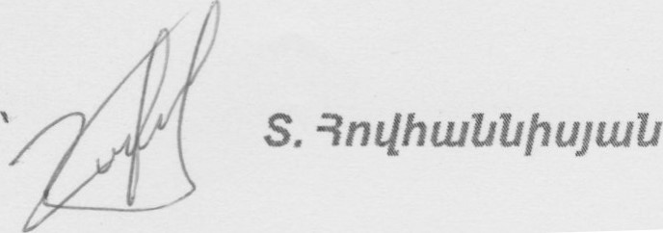1512ZıtPU111bZlQ t2ftg

Szþzuz Ilbzqpnzzf, qåulhzuznzlnll 0Ðb4znþí1 hunfzuqpbl 11 hzuzftuåzfzuå pzuzlzupzup pulåzullþ

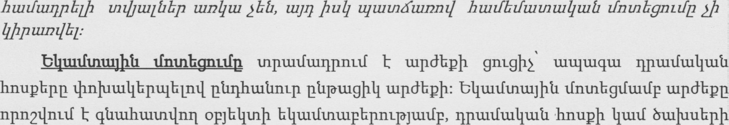

lulltujnqnumnúltlhpþ tupðbpþ hþlfultl Ilpuu:

b11u1tftnt11Jþt1 tfntnbgntlfp ulbtnp Ilþptuntlþ 11 qqull_þ 112þn utnultltll hbtn11J111L hultlqullfultlktlbpnutf

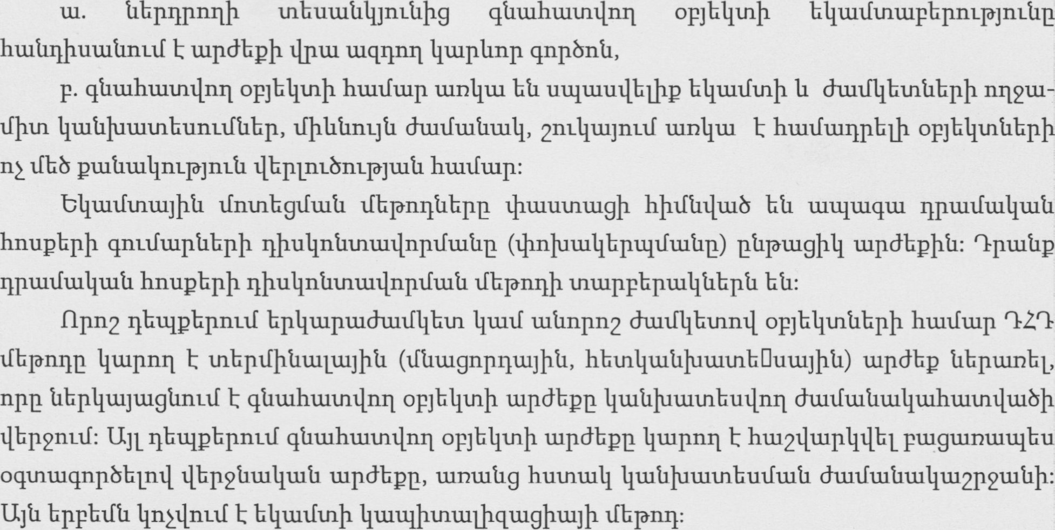

qåu1htuznz112Q zut12tupd qnypþû huzzfuzqpblþ puzzluzpzup puzåtullþ zþupdzuzþfzupåbpþ

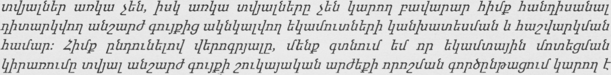

1117111 þlþuzn unzpjblltnþzl pånzjp 11 hulûqbgûbl zlþúuhtupnzjg zupwnzåpåbpþ: Ujuulþunzl, qtní1ÏILtf btf, np zntbtZ11 ultuptuquynzzf blltuzftntujþå zfntnbgtftuíl Ilþptunnztfp qåu1hzuznt111Q

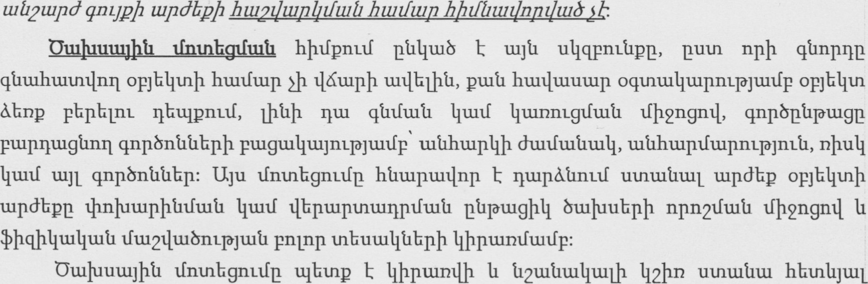

hultlqtlllfultlptlbpnttf.

#### Olltuhutnntl S. BnLlhub11þuJtuL1 (12-012/01-23

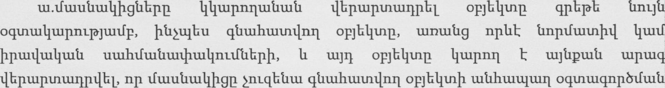

ht1tupu1tlnpnL1ðJu1t1 hullfup hultlh1J111L Ilúupbl,



tuntutl&tltuhultnnull pt1nLJ1ðP pnLJL yþ tntuthu b11u11ftnu1Jþt1 Iltutf hullfblftutnullltutl lfntnbgnuftlbpþ Ilþpunnufp,



Üü12tlu1bnL1ðJnLt1 (Upðbqpllntlf/žtltllgnutf) htuulltugntmnttlp tlbptupbpnuf ulJt1 nunnnL1ft1bpþt1, npnt1P þpuu11tut1tug11nL1f btl hullluuutup oqtnu111tupnL1ðJu11fp opJb11tnþ

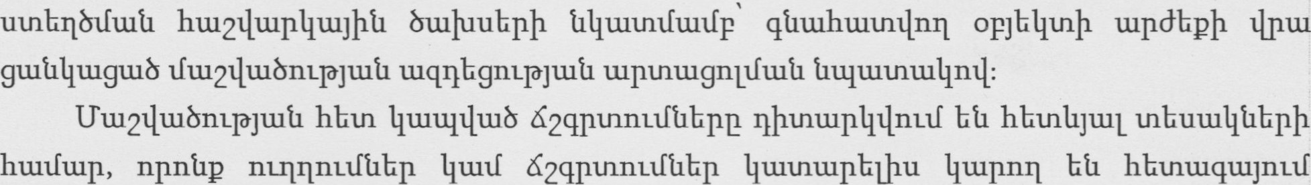

ptuðuut1tlhL htlpuutnhutulltlhpþ.

lfu1211uu8nL1ðJnLt1' qtltuhunntlnq opJh11tnþ 111L11f puuqulllpþytlbpþ lfu1211u1bnL1ðJtut1 ultuuúunntl oqtnu111uupnL1ðJu1t1 guúllltugulb Ilnpnuutn, nptl tunu12tugbL oquntuqnpblfuutl hbunlltutlpntl 11 tnuupþpþg,

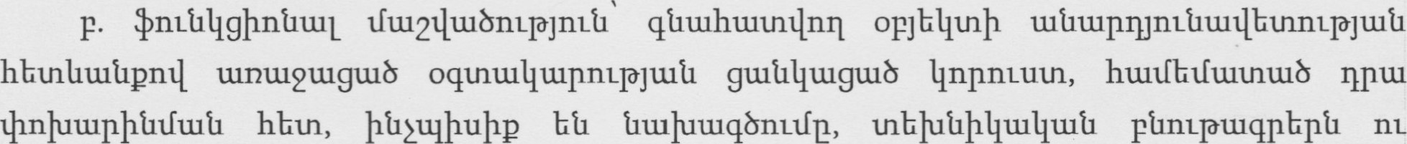

tnblut1nLnqþu1Jþ ht1tugtL18 Lþt1bLP,

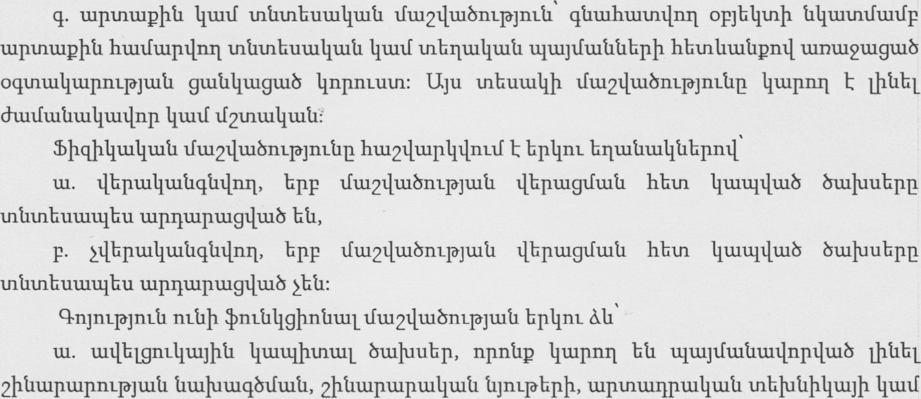

lfbpnlltlbpþ LþmþnlunL1ðJnLt1t1bpntl, npnt1P qtlulhultntlntl opJh11tnþ hullfhlfuutn ultlbl_þ gu18p



hultlqhgtlnuf,

#### Oltuhtutnnn

qtltuhtutntlnrl opJh11tnþ hullfhlfuun hl-utlqbgtlnuf dullfuúltulltullþg hullfuupðbp opJh11tnt1hpþ htuutut1hLþnL1ðJu1t1P.•

Stlunbuuulltutl lfu1211u18m-1ðJnLt1L1 Iltupnll uunu12uut1u1L, hpp upuntupþtl qnp8nt1t1hpt1

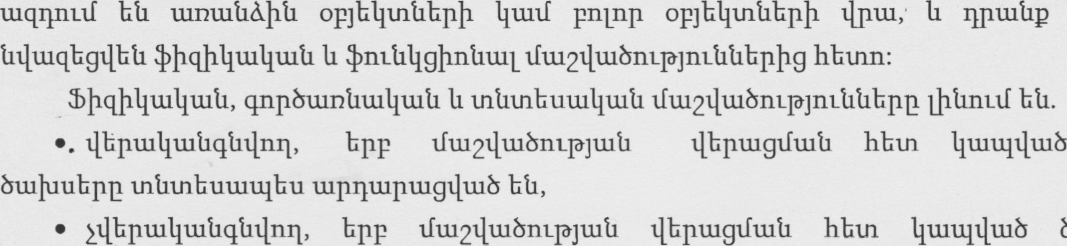

tntltnbutuulbu up11tupuug11u18 Ebtr.

Oulluuu1Jþt1 lfnunhglfullfp ult12tupð qnypþ 2nL11u1Juu11u1t1 tupðbpþ qt1u1hu1tnnL1ft1 þpuulltutltugllnuf hbun11Ju1L 1þnLLbpml.



npn2nL1f,



tupðbpþ 11 2ht1pbpþ nu 2þt1nL1ðJnLt1t1bpþ Ilhptupunulllplfuutl (Iltutf lþnluuupþtllfuúl)



Þåyqbu zlbpp [1211bg, ulå2tupd qnypþ qåtuhtuullfzuå ðu11uuu1Jþå Lfnznbgntlfp Ilþpuznblþu oqznzuqnpðzlnzzf k u4qpnzåpuyþå uytl zfnznbgnzzfp, bpp 211L4uyzu4u1å zupdbpp npnflnzzf t



Ifiü21þuðnzpJÏ2Låp.•

Uå2tupd qnzjpþ #þqþl/tul/tuå 11 #11Lå4gþnåu11 Lfuezltuðnzpjnúlílbpþ hu1211tup4p Ihpbûþg pzupqnzpjnzíl åbpl/tzytugånztf 11 nzílbíltuznzl qí1tuhtütntþ717 ahånzpjnzílílbpþ zlbptupbpjull puzzþupuzp ðuztlullþ þâþnpzfzugþzu /2þånL10]tuå zfbp Illiåuznpnzlltnþzl zntuppbpþ Iltuqzfp,



lfnznbqzfzuå Ilþptunnzzfp hþzfåzuz/npz/zuð t 11 4zntuþpzuznbutu11tut1 zupwnzåp.•

### 2.10 Lt11tluqnLJt111 unu1tlbL tup1ÐnLt.1t11tlbtn oqtnu-lqnpbnttf

E, npp htluupulllnp k, þpullluupuutlnpbtì pnLJLuuunphLþ, å)þtluutluuuulhu þptuqnpbhl_þ 11 tuultuhntlnuf tut12tupð qm-JPþ tunu111hLtuqnLJt1 tupðhpp:

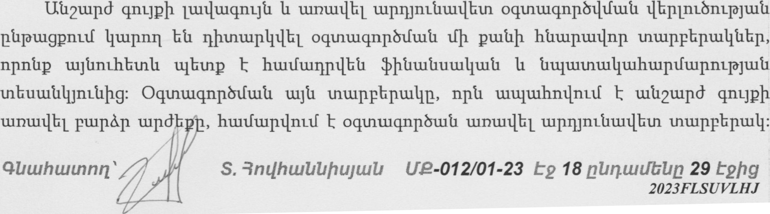

lautltuqnúl 11 tunu1t111L tupmnutlultlhun tntupphpulllþ pt1tnpnL1ðJnLt1p qtltuhunnnnþ



2111211/1 tuntlbznll qåzuhuzznzlnll Lüt12tupd qnypþ Ltlblltuopnzpjnzåp, Lf1bþ1t1þ4tu4zuå znzþullåbpp 11 qnpðzunåzu4zuå t12zuåu14nL1ò]11Låp zlbppþåþu Ituzlzuqnyå 11 zunzuzlbl zuplynúltudbzn oqznzuqnpðnzzfp påptugþll (npzqbu zqzuhbuzn) oqznzuqnpðnzzfå t:

qm 3. Cm zu zu uzå uz db hu zu

3.1 Ou-11uuu1Jþt1 lfntnbgnuf

Ut12tupð qnypþ qtltuhtutnlfuutl bulluuu1Jþt1 lfhntnbgnufp þpullltutltugllnuf hhtn11Ju1L hu12np11tu11tut1nL1ðJu11fp tu) hnqullftuuþ 211L11u1Ju111u1t1 upðhpþ npn2nL1f,



lþnlutupþtllfuutl) bulluuhpþ npn?nuf,



q) tut12tupð qnypþ 211L11u1Jtu11tut1 tupðbpþ npn2nL1f, npulhu hnqtutftuuþ

211L111LIJu111tut1tupðhpþ 11 2bt1pbpþ nu 2þt1nL1ðJnLt1t1bpþ tlbptulltutlqtllfultl bulluubpþ



2nqzuzfuzuþ zupdbpþ hzu2tIuzp4 / Ch /

SLIJIIIL Ilhtypnuf tut12tupð qnypþ uultuutuplllfultl hnqullftuuþ 2nL11u1Jtu11u1t1 tupdbpp



utuplltftutl htutfuup hnnullfuuuþ 2nL11nLJtu11tut1 tupðbpþ npn2tft11t1 hunfuup, htutfblfunntfultl 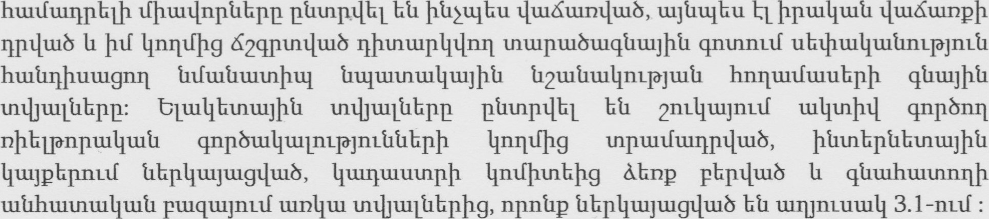htuufuuqpblþ lfþtuulnptlhpp ptltnpulhl þtlžulbu ultuúunuluub, ulJt1u1bu þpullltutl ultuúunpþ

Utnnpll tumnuutull 3.1. l-nL1f tlbp11u1Jtug11uub htl hu11ftuqphLþ lfþulllnptlbpþ hullftunntn ptlnuptuqpbpp.

¼tuuntuplluub nuunL1ft1tuuþpnL1ðJnLt1t1bpþ 11 Ilbptnubnumnúltlbpþ tupmnúlpnuf



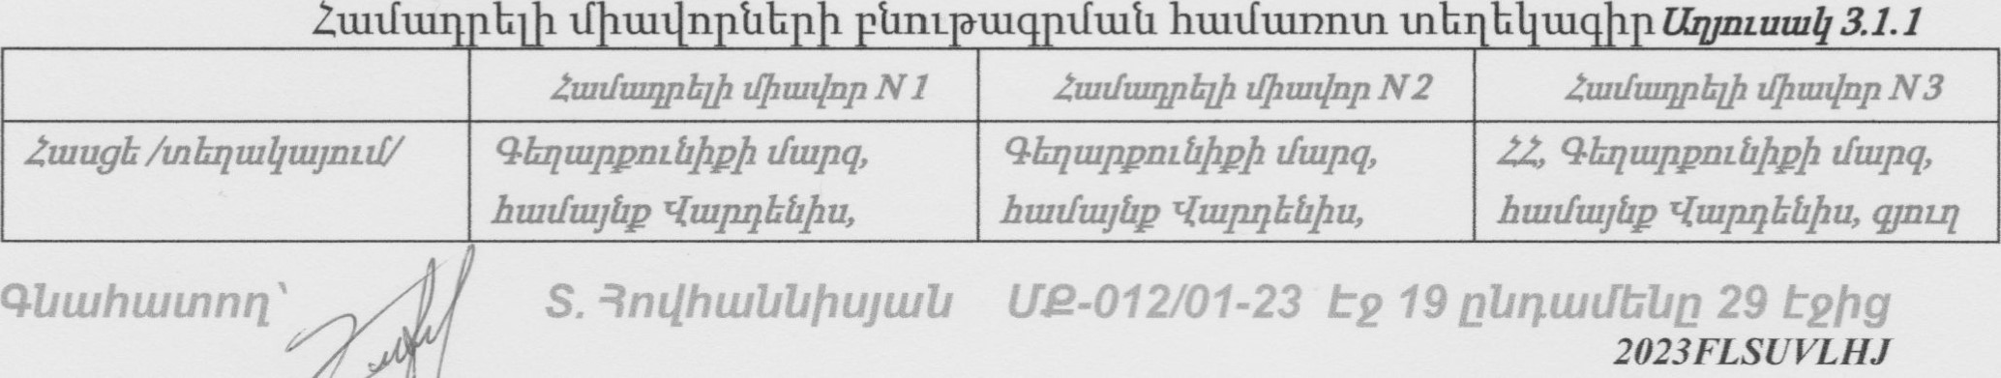

n

|  |  |  |  |
| --- | --- | --- | --- |
|  | (ЬпЬшррЬђЬрф ф.па. , plnl2 | 9шјф фпа. , 6-114 Ьрр. ,  15 | (тиш4тЬр 1-фЬ ф-т?. |
| ,9Ь7Ь4шшч1трјшђ шарјтр | *ЬђшшЏшђшЬрищш | *Ь4шшфиђшђричш | $Ь?ЬђшшЏшђшЬричш |
| 2дчшьГшиф ьГш4ЬрЬир, р | 1800 | 1330 | 1000 |
| 2пчшьГшиф ђщшишђшјф  ДдиДчиђтрјтђЕ | ВЬшђшЏшјрЬрф | Вђшђшфијр&рф | ВЬшђшфијрЬрф |
| 2ппшьГшиф рр&шпђшђшђ Д'2шЬшђтрјтЬд | Bt1tulI&lh ршппщшчшшьђиђ | Ft1tu4bl_b ритпщшчшьтьГшђ | Рђшђђф ритпщшчшшьГшЬ |
| Чш&шпрф /шпчшр qht1 ,/22 пршШ | 1300,000 |  | 300,000 |
| ЧиТшпрЬ/шпшешрђф чшјьГшЬ | Ипшршр4фрш4шЬ qtmzl | Ипшушрђфршђшђ qtmzl | ЧшХшпфи& |
| ЧиМшпрД/шпшршр4ф шьГишрфЏ | 20.04.2023р | 20.04.2023р | 20.042021р |
| 2ппипГшиф Ирш шп4ш ршрђшЦпиЉЬр | Ипђш ђфишђшптм  211fmzpjnzt1 |  |  |

qtnuhunnqnn №ut12tupd qnypb 2btmtpjtuil ичшишрЧбшТ1 hunftup hnnunftuuF 162 tupdhpF h1L12qtuptlE k2qpunftut1 qnpbtutlbgtlhpb №fbpngnq pkpqtu8 Е plnl З. 1 .2 шпјпгишЧпг№Г .

Sbnti4u1tf1lu1l]tui1 ptuquynuf шпђш шфшДIЬрр, прпђр oqtntuqnpblbl Ьђ qi1tuhtumtft11i1 аиьГшђшђ ђЬрђшјшщ/шД Ьђ hunlblltu&nuf.• Иштишђ 31.2

|  |  |  |  |  |
| --- | --- | --- | --- | --- |
| ЧЬрит4пд hNnuuu.1tl qnpbnt1t1kIlE | qtnnhunnqnq орјКЦтв | орјКЦ1.п u-ltnutnq | орјКЦ1.п tutnutnq N  2 | онКЦт tutnntnq N з |
| <шЈЬЈшк.лшЦшЬ орјЬЦ(.лђ htuugb /клЬлшЦшјпиУ | 33, 4Ьлшррпе1.фрђ  (Itupq, ТиЈшј№р  ЧшрлЬ№ђи, qjnut  ЕпеишЦпе1јр 6 | 4Ьлшррпе№ђр  Lftupq,  ТиЈшјИр  '4шрлЬ№ђи, фпл., рђЦ 2 | 4ЬлшррпИ.фрђ  !.ftupq, Тијшј№р ЧшрлЬ№ђи,  4шјђ фпп., 6-ВЛ Ипр., pFLl 15 | 4Ьпшррпе№ђрђ  LItupq, тијшј№р  '4шрлЬ№ђи,  4јпщ  [леишЦпеИр 1фпп. |
| Чшбшпрђ |  | 1300,000 |  | 300,000 |
| (ЈшЦЬрЬиа (ЕИ.) | 40089.30 | 1500 | 1500 | 1110 |
| ПеллЦшЬ 1 рј. qNJQ (лршШрЈ) |  | 733 | 667 | 270 |
| ЪщштшЦшјђИ  И2ш№шЦпчэјпеИп | ИршпеИшрЬрпчэјшИ, nUnbnpoqL.muqnpbLItu1J  LL ШП шртшлршЦш№ | РИшЦшЦшјпЬрђ | РИшЦшцшјрЬрђ | Р№шЦшЧшјрЬпђ |
| 4прЬшп№шЦшИ  И2шИшЦпчэјтЉп | УпитштИтЬишЦш№ шрепшлпшЦшИ орјЬЦит№Ьрђ | ЦшппщшщшииГ ши | ЦшппщшщшипГш | РИшЦЬ[ђ  Цшппщшщшишш |
| Мфпфищђшјђ шлрјтр |  | ши рищш | Sbnt;LltuuulL.uuuJ  И рищш | рищш |

#### 4Ьш"штпп 'S ЗпЦ}тшИИђијшИ И2-012/01-23 €2 дИпшЈЬЬд 29

|  |  |  |  |  |
| --- | --- | --- | --- | --- |
| N 1 qw6wneh |  |  | _50/0 | 0% |
|  |  |  |  |  |
| 11Lnr11-lwb 1 PIJ qþlun  WIJ/ |  | 697 | 633 | 270 |
| N 2 ALU6LUneþ ðuúubwlltuhwtntltu |  | 00/0 | 00/0 |  |
|  |  |  |  |  |
| f1Lrnlwb 1 qhlln nnwü/p |  | 697 | 633 | 284 |
| N 3 Fnui1-lnLúpúbn li uwhúwúwthtuUnLúúbn |  |  |  | 0% |
|  |  |  |  |  |
| _f1LnnLlwb 1 ALI. qhbn |  | 697 | 633 | 284 |
| N 4 qnnðwnúwUwú  QwúwUwrupjwú (0/0) |  | -100/0 |  |  |
|  |  |  |  |  |
| f'lLrnlwö 1 21.1. qhLlQ |  | 627 | 570 | 255 |
| N 5 UwL1bnbuþ  62qntnnLLI (0/0) |  | -40% | -400/0 | -400/0 |
| 11LnnnLIIQ (nnwd) |  |  |  | -102 |
| nu-v-ll-lu-lb 1 pd. qþlun wel/ |  | 376 | 342 | 153 |
| UntrnLUhUwgþw11bp |  | -50/0 | -5% |  |
|  |  |  |  |  |
| 1 put. -qþlJQ  WIJ/ |  | 357 | 325 | 153 |
| PwnbUwnqnLdbbnþ búpwUwnmgqwðeúb |  |  | 00/0 | 00/0 |
|  |  | -71 |  |  |
| nu-nlwb 1  WIJ/ |  | 286 | 325 | 153 |
| N 8 Snwúut.qnntnwjhú htuuqnggllbph tunUcujnLÎðJt1LU (0/0) |  |  |  |  |
| nLnnnLIJQ (nnu.ll-f) |  |  |  |  |
| nLqr11-lwb 1 PIJ. qh11Q |  | 286 | 325 | 153 |
| N 9 Sbr11.unnnLtðJnLlJ (0/0) tnbrvuUwJtrwlJ qnwtbnqð nLl.1 |  | -15% | -15% |  |
|  |  |  |  |  |
| fÄLnr11-lwb 1 qhluo |  | 243 | 276 | 153 |

qutuhunnnn Ep abnu.1tTbba

|  |  |  |  |  |  |  |
| --- | --- | --- | --- | --- | --- | --- |
| N 10 |  |  |  |  | 100/0 |  |
| A  (ILnnnL1fo (nnwü) |  | 49 |  |  | 27.6 | 54 |
| nt-nnulwð 1 211. qþlJ0  Wil/ |  | 292 |  |  | 304 | 207 |
| N 11 fðben1-pjnLl.1 (0/0) |  | 00/0 |  |  | 00/0 | 00/0 |
| (nnwtl) |  |  |  |  |  |  |
| nLnrNwb 1 pur. qhlun |  | 292 |  |  | 304 | 207 |
| Alltuhunntlnn qnLJ2þ 1 211. u.iPåbeo |  | | 273 | |  |  |
| Abu.lhtutntlnn qnLJeþ |  | | 10,951 ,427 | |  |  |

Umnuutullþ tntbu1Lt1bpþg hpllnuf E, np qtltuhunnulnq tut12tupð qnypþ 2þt1nL1ðJtut1

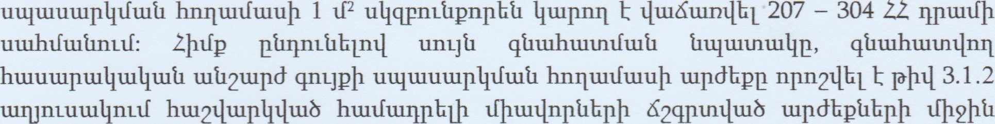

112nu1Jþt1 lfbbnL1ðJuut1 hu12Lluup11tfu1tfp, npp hullftuultutntuulututltuptup Iltuqtfnuf lif2



Ch=SxN, npunhll' N' lif2 hnqtutftuuþ lfþ2þt1112nu1Jþt1 tupðhptl E, 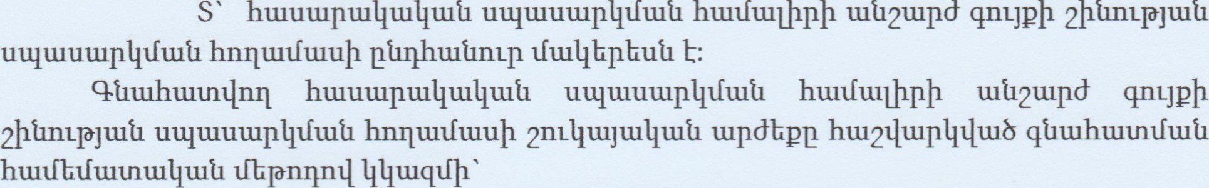htuutupullltulltutl uultuuuuplllfultl hultfüllþpþ ult12tupð qnypþ 2þt1nL1ðJt11t1

Ch = 40089.30 x 273 1095142722 

Cþünumnúltlbpþ tupðbpþ hu-12tltup11 qtltuhtuunulnq tut12tupð qnypþ 2ht1P, 2þtmL1ðJnú1t1hpþ tupðbpp hu12tlu111bL bt1P tunu12t1tuhhpp ptltnphlntl Ilhpuuptnulllptftutl btuluuhpþ lun2npuug11tu8 gnugtut1þ2Ü, npþg hhunn hu1211uup11hL hüp Ilhpuuptnuuqpuftutl bull-uuhpp•. Öht1P, 2þt1nL1ðJnLt1bpþ 11bptuptnt111W1ftut1 bulluuhpþ huumluupllp þpuu11u1t1tugpbL hüp hu12Llþ tunt1hLnul unlupuntlulbnumultl uuutnþKu1t1Ü, hup11u1Jt1nL1ðJnLt1p, hþlftltulllftulupp, 2tupuluu8pp, btubllhpp, btub11tut1Jnupp, tlhppþtl 11



tutfutuptlþ npnumultfp) 11 ulJlt1:

'11u1Jtfu1t1u1Llnp11u1b qtlulhultntlnn tut12tupð qnypþ 2bt1P, 2þt1nL1ðJnLt1t1hpþ



C,ht1P 2þt1nL1ðJnLt1t1bpþ tlhptuptntuqptfllltl tupðbpp hu1211tup11bL bt1P ht1tn11Ju1L Ilhpul

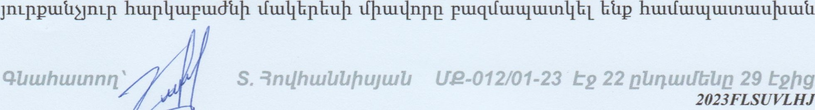

hmplltupulðtlþ lun2npuug11u1b gnLgu1t1þ2n11: Utntugtlulb mpmnúptlbpþ huuultlpulqnufuupp Iltuqtfnuf ulpðbpp:

8u11uubpþ hu12tlwp11þg hbunn Illiltnt.uptlbl Ifi112tlu18nL1ðJnLt1t1hpþ lfh8nL1ðJnLt1t1hpþ hu1211uup11Ü, npp tlhpuunnuf xþþqþlltulltutl, 11 tupu.ntupþtl lfu1211uu8pt1bpp hullfuuultuunuuluuutltupuup:

#### üu12tlu8pt1bpþ htlltftunntn tllltuptuqpntmnútl nu IlþptunnutfL

(qnphuntltuhuúl) 11 tuptnuupþtl Intitnhuuulltutl lfu1211uu8pt1t1hp:

* $þqþ4zu4zuå zfuezþüðnzpjnzåp 2båp, 2þånzpJ12Låbpþ z/bpzupznzzll/pzfzuå zupdbpþ åzlzuqnzzfå 'hþtfåtulltüånzzf IltütqzIzuð2båpþ oqznzuqnpðzfulíl dultfllbz.nþ hbzn:

UntJt1 lfu1211tubpp Ilþtntupllblþu tlbpuuptnulllptfultl tupðbpþ tltluqbgnutftl IltutntupbL bt1P oqunuuqnp81fu1t1 hunfuup: bþqþlltulltutl lfu1211ua8nL1ðJnLt1 bt1P Ilþunuupllnuf tlülll 2bt1Pþ

* $nzllågþnûull zfuezlzuðnzpjnúl 2bûp, 2þånzpJ12Lååbpþ zupdbpþ åzlzuqnzzfû Iltuulllzuð znbþ1åþ4uz4zuå ånpuzpzupnzpjnzååbpþ, duzzfzuåzulltullþg zyu1huzå2åbpþå

lfu1211uugpþ t111tuqhgnL1fp hþlftltulltutlnutf IlþpuunhL hüp 2ht1P, 2þt1nL1ðJnLt1t1bpþ

* Síltnbutüllülå zfzuflulðnzpjnzå tupznwpþå zfþ2tuzluypþ ultzyzftuûílbpþ zþnzþnlunzpjtüíl u111ÏIJÏ7Låpnzzf2båp, 2þånzpJ17Lååbpþ zupdbpþ åzþuqnzzfå t:

Stltnhuulhultl lfu1211uugpþ titluuqbgnufp hþlftltulltutlnuf 11þpuunhLþ unb11tu11u1J1fuut1 11

tu) QIlbpu111tut1qt1tlnrÌ lfu12tltubpþ Ilbpullltutlqtlntlfp tntltnbuuuulbu tuplltupuugtlulb EE.

Ilhpuuptnulllptfultl tupðbpþ t111uqbgnL1fL1 Ilþptun11bL btl lfu1211u18nL1ðJnLt1t1bpþ lfbbnL1ðJu11fp

tupunuupþtl tntltnbuuulltutl lfu1211uu8pt1hpþ (EO) qnpbuullþgtlbpp 0/0-ml, hbun11Ju1L hbpptulltutlntpjultfp:

U ntutll 3.2.3

|  |  |  |  |  |  |  |  |  |
| --- | --- | --- | --- | --- | --- | --- | --- | --- |
| 2/2 |  | s /ptf/ | tiltf/ | v/Ž2 unf/ | PD/W | FO/Oh/ | EO | V/Ž.2r111tutf/ |
| 1. | 2bbe | 316.1 | 170,000 |  | 35 | 55 | 35 |  |
| 2. | ml.uhbutn | 354.1 | 100,000 |  | 35 | 55 | 35 |  |
| 3. | rntuhbutn | 210.0 | 100,000 |  | 35 | 55 | 35 |  |
| 4. | 'T)whbutn | 28.3 | 95,000 |  | 35 | 30 | 35 | 611,634 |
| 5. | 9 nuLlwqu.lll | 136.2 | 25,000 |  | 35 | 55 | 35 | 221,325 |

Obtuhutnmz  t2 abqut1TbUa

|  |  |  |  |  |  |  |  |  |
| --- | --- | --- | --- | --- | --- | --- | --- | --- |
| 6. | 'Tlwhbutn/  9 W W Lull | 87.4 | 25,000 |  | 35 | 55 | 35 | 142,025 |
| 7, | 'Tlwhbutn | 66.6 | 70,000 |  | 35 | 55 | 35 | 303,030 |
| 8. | 'Tlwhbutn | 106.7 | 90,000 |  | 35 | 55 | 35 | 624,195 |
| 9. | 'Tlwphuu.l | 160.3 | 30,000 |  | 35 | 30 | 35 |  |
| 10. | 'Tll.unhuul | 3.7 | 20,000 | 74,000 | 35 | 30 | 35 | 16,835 |
| 11. |  |  |  |  | | |  |  |

Cl=Ch+C2

Cl— Ötuluuu1Jþt1 tfbpnllnuuf 211L11u1Jtu11tut1 tupðhp

Ch — hnnþ tupdbp

Q— 2þt1nL1ðJ111t1 mpðbp

Cl = 10951427+ 10155812

Cl =

1.1Lnptugtlu1b

Cl = 21.100.000 22 IMIu11f

qutuhutnnn anzlhwbbþujutll t2

### qznzlu 4. qåzuhzuznzfzutl zunzupzuqpuzåpþ



tu

nzå

tlb

uut12uupð qnypþ 211L11u1Juu11tut1 uupðhpp huzzfuyåpuyþå ubzþzu4uzånzpjnzû hz.uå11þuzz1A tuå2tupdqnypþ ozntupzfzuå hzuzfzup :



tupnJ1)Lt1pt1bpþ hultftu&u1Jt1bgn1-tfp hþtfp btl unull_þu bqptu11tugt1bLnu, np 22, qbnuppnúlþpþ lfupq, hultfu1Jt1p  qJn1.11 Lnuuulllnúp 6 htuugbnuf qtntltlnn ult12tupð qnypþ 211L11u1Jtu11tut1 tupðbpp s um 20.04.2022p., Iltuqlfnuf

qtltuhultnnq

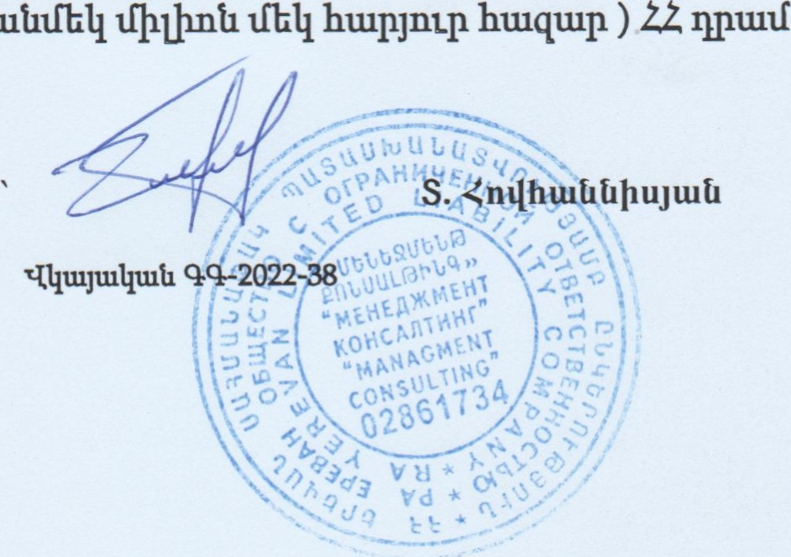

21.100.000

(

putut.ltfbll

411tuhtutnnn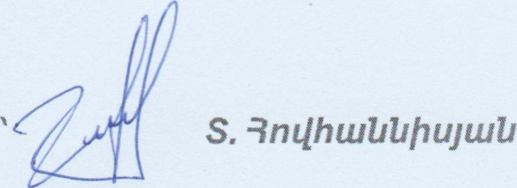Ute-012/01-23 

(-.(tvzupd qnvp11 qt1tuhzuznzfzut1 ћшьГшр 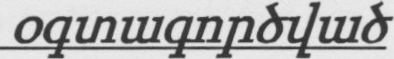фшиишрпрђф, ошђш&пџајшђ [1 иЬ4Ьђшьпч1пчајшђ шпрјпчпђЬрд gt11t10p

1. «L(t12tupdqnzjp11 qi1tuhtutI1lftui1 qnp8mi1bnzpjtut1 ьГшићђ» 22 орЬђр:
2. 22 ђшпшЏшртрјшђ 24 oqnumnuh 2022 ришђшђф лг 1355-Ь «2ИВИИ9ИЬћ гиьгита;пьрзпь ьтт и  ьъиьаињььгс, ћЬ2ТЬИ ьиьч 4ЬИ2ЬЪП[2ћ чигрИ4ОћЪ ЬЬГЧИВИЗчта ТИ2ИЬ2ЬЬГС лцьгиььцјћ ИИЬФЬ»

З. SbIlblltuznlnzpj11LtlE шпшушр4ђЬр/1 ЦЬршрЬрјич nzunufiltuuhplbl vvww.List.am vvww.Estate.am vvvvw.M еа1 . ат vvwvv.Ara •ark.am [1 шпћЬшЬрђЬшшјф& 4uypbphg.•

1. SbIlbQunnzl17L17JI11i1L1 u1i12tupd qnzjph шЬчш4шјьГшђ ЏЬршрЬрјиц 22 шпд&рЬр 4шјрф9. ' www.e-cadastre.am
2. (-Ii12tupd qnzjph К4пђпьГф4ш 4шпшЏшрпиГ- (ЈиЬфшЬјш& U.6., 2пфђшђЬфијшђ Ч.

Ф., qphqnpjtu& И. 2007p.:

1. Анализ и оценка проносящейдоход недвижимости Д. Фридман, Н. Ордуэй 1997г.
2. Оценка имущества, А.И. Зимин, Москва, 2007г.
3. Оценка недвижимости А. Грязнова, М. Федотова Москва, 2007г.
4. Оценка недвижимости, В. Швандар 2008 г.
5. Оценка недвижимости. Учебник, А. Грязнова, М. Федотова Москва, 2002 г.
6. Оценка стоимости недвижимости, Е.Н. Иванов, Москва, 2007г.,
7. Оценка недвижимости, Л.Н. Тетин, Москва, 2012 г.
8. Оценка недвижимости Г. Харрисон 1994 г.

#### 4Иш}тшитпп ' -ЗпфшЩ'шјшИ

|  |  |
| --- | --- |
| 2UrZbL |  |

2zuzIzuqphffı znzbzuı 1

5390,000

|  |  |
| --- | --- |
| Znnunnuıpuıöp pütuL4Ğlh '-Luıpnblihuntü, 1500 puf. | hı.uüuıp |

534.000

hnnu.ıuuupcuöph ÜLUUhI•

15üC 5170,000

I„nnu.A.nwpu.ÂE2

573

537.000

21uüzuqphff2 znzÜü1hh znhııulııupzü

9bnıuppıuüFp çiuıpııbüöu

quuıhuıınnrz RmlhwZıZıhujuıZJ t2ftg

Zıuüzuqphth znzbıuz 2

Znnuıunupcuöp Qlınhculmıp oqmuqnpöüuılı 4-1cupnĞUhunıü,

1500

Ç 'ü-üunqşühu 11000,000

hnııunnuıptubph ÜUJUh11

CürçhLLUnxp cqunuuçnpğüvuü

üu.'igğnöuc

Lğuıputqhp

2-nry-uş-nwpwögü g. Ahnnng 6-991.ıppwügg 15

VÜLUIı:LUU1hg

çın;

4Eûû 2.ü.

2zuüuuzph1h znzÜıuÜ1 znhızu4uıpzÜ

Ş.

quuıhuıınnq 3nılhuıZıZıhuyuıZı 29

2,zuzfzunpti111 ифич З

<плшсшић шппЩшбшп2ђ qnnbeunph итЦјш№ерђ чершрЬрјщ

<ьгпичиъ 4828

U)2tupd qnygh hwugb' Ju.',qq 4ЬпшрртЬђ2, }тшьГшјЬ2 (пшшЧпШр, 1-ђЬ флапу

(Ирбшррђ шоишрђ"д' 20.04.2021

Чшбшпрђ qhbE' 300000

|  |  |  |
| --- | --- | --- |
| <плилГшиЬр | |  |
| <плшјщиђ ошЧЬрЬиа (ршпшЦпшЬ [Жир) | | 1110 |
| <nt1tuJtuuh t1QltutmulquJJhtl ti2tuiJtul,tntpjmtJQ | | РЬЩЧШЦШјРЬРЬ |
| <плшЈщиђ qnn&untnutatutl | | Чшппщшчшшјшђ |
| <ппшЧшгнщшлршјђЪ q№LUhLUU1JLUt1 | | lJLLtuti |
| nnnqbLhntpjnLtiE |  | tut'2pqt1 |
| (пф htupt4Lfvutl | qnu*ti |  |

шфШ1ф иђшђшјпшГ

Лусакунк

4Иш}тшитпп S -3пфшИИђијшИ И2-012/01-23 9 ДИПШЬЪИД 29 &2hg

CU3UUSUUh

# LLğU3UğUU

UUCUPö U9USUUUP mıjsuquu 9PUL3UUU lınıflııph

LII!ülJtuIıuıtınıl huıuınuıunılnıd k 14 tuıqphlh 2023 qnııph bğunnüwüp hpeuulntüpübph xuıbunutlıuıtl qptuügduıü üuıuuuıÜnıÜ lıuıuıuıptluıö ıuİ.12vupĞ qngph L'lıunnüuıüp hpunlndıph uıbuıuılıuıü qpuıiıgmüQ .hüunlıyul

ı. qpuusquu hPUqrıtxUPh UfıtxP3b9S(UbP)

|  |  |
| --- | --- |
| « uııpah | 41.1UU3U$2 |
| 2. UUCUPĞ | 4U3PQ |
| Utupq Clbnuıppnıühp, htuüüiJtıp | qyurı L»nıuuılınılap 6 |
| 3. ÇPUUSUUU CUUUP | CUUNhUU3Uü QUUSUıanıöbPQ |

13.04.2023p.N220-ıı

I 4. CfVIUUUUh 1

l-ttülluıuınptü)ihtl 05-043-0104-0002

## (hu)' 400893

UgunnıulaujJhU luptunıiıvupbpnıpjuıü, punbppoquuuqnpöÜuft1 bl LüJl uıpınuıqptülıuılı qnpöuxt1üQilıuıtg trecuüQILınıpjntüQ lituü hnrııuı.nbupo* LupuıuırıpıuğüiZJ opjbğtnbhph

•qpuıtıgQcuö hpülllnıtıph UbQllLiUlUf1İMö3flblJ

## N 1404202305-0095, WMFZGYQJJCWU

hulımpjn,LQ h t' utpnıçQbi

1/2

5. chl,nMð3ntx1JLb0h pt,ntýðuqrerc

L

I) IJtqužu1Lu11u.ijhti

2) Püntptuqpbpo nur-n tuntusuðþtl

|  |  |  |  |  |
| --- | --- | --- | --- | --- |
|  | Gutt)ututnpu1Jþti ðtuðtltuqþp | Sbututl | IJtu11bpbu | qpcutlgtltuå hptutlntúpþ tnbutuL1 |
| 1 | 05-0430104-0002-001 | 2btlP | 316.1 | (Jbouquuntxr&311NIJ |
| 2 | 05-043-0104-0002-002 | rmuhbutn | 354.1 |  |
| 3 | 05-043004-0002-003 | rntuhbuun | 210 |  |
| 4 | 05-043-010480002-004 | entuhbuun | 28,3 pú |  |
| 5 | 05*043-0104-0002-005 |  | 136.2 |  |
| 6 | 05-043-ot04-0002-006 | ertuJhbutn | 87.4 |  |
| 7 | 05-043-0104-0002-007 | LfTl(Uhbutn | 66.6 |  |
| 8 | 05-043-01040002-003 | muhåuun | 106.7 pú |  |
| 9 |  |  | 320.6 | utouquuntýòantxl, |
|  | 03043-0104-0002-009 |  | 3.7  4,81 | IJbouquuntxf?3nnu, |

Lptugntgþ£ t12ntút1bp IL Ltnbnb11n1tðJn1tit1b11

mqptutagruúo hptul/tuùugùnrt tqtü2tnnt1tuunž-up tutJnttJQ, tuqqwbntt1Q' UPQh1Jb '11.1QUP3UIJ

Qptutlbgptuð 1.1ù2wnå qntjpþ úthtuutatulltutl qntJ2þ cutltuq nbqþuunp

## N 14042023-05-0095, WMFZGYQJJCWU

mvw.e•dostre.om

E2 2/2

|  |  |  |  |  |  |  |  |  |  |  |  |  |  |  |  |  |  |  |  |
| --- | --- | --- | --- | --- | --- | --- | --- | --- | --- | --- | --- | --- | --- | --- | --- | --- | --- | --- | --- |
|  |  |  | っ2っさ5m5コョ》 | ,こ~ はびせデ3一一「らョソ | ご(→を互ミプ = 一ラ |  | 0  2  ~0けー |  | 0034」ョ5 ョコ | っ冒ニを5tÄf)を?を導3一ョ」一」 | 号き5ミ)=三=三プ |  |  | 4 唇」いし |  | | | | |
| 身 4 | 「旅(ぎ当、 | メい顰一 ド  ま当 | | |
| 、  を |
| 村みを |
|  |  |
| をョ「当(当3=ュ「三ラ0ョ20=ョ= | 三気き巨bョを5コ | | ロっ 〕ョ(r)三をョ ョ0三豎)ョ(ぎ | 2》ブマ | 三ラ三をョニ05コ | 焉 ・ 9 | んミ29こ | |
| oニ0nhnSコ》 ニっnココ U》 | = )洋をき三一ぎ(きを当一.=」ョ))言()す一 をらニ | 三 0び当コ | 発当3羲ョ23 三「) | 辷 0 3=当′を0 |  | = ミを与当 | 三( を一  を.、三一ョ三(を | |
| 一ミ )ぎ当一 | | |
| にコnnnbIJ》 | (3 を三  (嶐00 | |  | ,  、  0  ・  01  ・  を  つ  =  、  0  )  三  0  —  =  4、9  一、9ビ | | | | |  |  |
|  |  | .ミ雅 096  勹尊  「04旅 33 933一、に目9 旅旅、09  、き、09旅  X | | | | | |
| 0=ーケー【=一4曇に=暑ま・暑壘青ままを一き0k一、き4  ミ← :、[6:  目 ま 8  ミ0一00こき戸べへ粤一8606当円朝、0 一」k. ,5当トト0一.  に一トら 9 | | | | | |
| を彎当  号き当)  を3?ー村えき |  | | 、 | |  |  |  |
| 鬯 0 | 当 こ←0め デ, | 一当ラ論三0ョ5ニ3  」 )をらラ当(ュー~一 言一1  (ま 尋 こ巨コ | | 、~すゼを ミを イ=  )言こ(一ョ5ニ「)三ミ | | 当当を、 を一 一(3当「 をゴ0=、をき~~0 ~0=」 (=」ミゴさ0三一)~三 | | | |
|  |  |  | oミ三三02さ一を(=)テ |  |  |
| ( ~)デを ョn | | oをbョ言ョ0 | 一ミ導当ョ0ョ 0長ョュョ5ョ2 | | COこま当ョ0ョ30ョh30ョ0を0 | 3 イ を当 、き一を目 一「ヨ 当ョ「 |
|  | | | | | | | |  | |  |  | |  | コ | | | | |

と ⅳ9ロ を=ョ三ヨ一一 一一をコ)号ョ 言三0言 =、

コ ョ 朝旅。旅なミミトミ.、0を=旅0ききミ、Vト、,一ト0き0 ,ーも0 と2さき~0・日 ! 言一~ ー一二ツ一 一

ィ一 ま.一.、三ミ0 ,へ拿置、 ない 一、日しト幸、 =を )を5コ 、,00ミ0

ン れ

2 を リ 容もニ ミ を きををな) も00 ッ お0 、 ミみに-

。、当=言=ョ3 0当: 0?を 当ョニ ョ0ョhョ冒→こョブ当」に コ3」」 霻

三こラを()ラ」舅、コ 0 こ「 0、一 一 総 0922( まお -

( 「一) 460 (薈20( 「0~2、 【壑3q2

,4一「11 岩 をさネ尊 をを 三を与ョュミこ C一 一 一さ39209V0当0三、一、6 9 cーネ3朝 き 勹。 ミ(・らを一0な鷺・09当い 0

の

ー

鯊

0

を

0

ー

きョぎ30を?ut一丹ョhョ」u CYYg 20き・9)n09:・、0、24独)、三((ミ6、'0《をきト0 拿・、旅0当ミ一三ミ~ミ薈ヾ当、哥、0 旅用一朝、朝

巨0きラ三 き「一【ココ当をきプ 」ざ3= ラ 箋言み 三コ 0ミラ

一号三ゴ やを0計

「長ョっ0

三=」mミ、

を 三ミ一言きさ一三ま一イ騫、 05言.0593 0ト01 .、0 , 「092三00 。、に言L302 86 ミミ一・ミ05 三三ミ0=当をき、01 3べ0 、4、 3、啼 な三0目

92、一 (-目ミ40 0新 : =0三 0 卩ッ0は0に、をに、090、 当、、き、円ビミ三←当朝い当円 0.ーを

を←、ミ0

巨日をつミ を当 ゑ2言0 ら~言当 き,) 当朝を、盞~ミ彎一 。な4ミミ090 、煢04「0をド:0い目ド

* 区503をを言) を 、
* 長ョっ0 0 き彎「を新「三-ョ三当、0 0を一,三 叮

当 ま02、0い ~ 、き っ 00一1

0 4 0二一一 宿05説 、ミき一き00目

(3ョ三をミ 05ョ 巨(一(ラ 0 0「を当、朝 一きを 、 き

きべべを朝 、、 き一2旅勹 きら (一(0」0ュ を0」0当) き、ミ0 一、、鳶をに.1-0朝新 、考4旅を

m三 三プい

C.ミ「、00( . ヾ00ビま.6新 (っ)とを」癶 を ををに

0

# 勹一 -0009k2.,99に三、をき 当合、目 、一、、 0当

当き一0(さ0 。き0をまミ0き@ ョ3言ご1。 "06目8ー,2一 2ミ 0606ヾV09tを01、0当2 ド目 当いー新一

3ミべ000壽 、0 ().ミ)ま三= へま 一40ら一)さまを4三言.0っ 22をミをマ ミ、貳朝当

《20一 、雅0三200000目ヾ、トt94( ト三新ミミ00きド 0 : 04き1L0、を:一 き0三ま当9新 を いを・言三さ鳶2B080 、、きま、ユ「を、、ミ《《090当「

ミ・6 の要を)一一に、003当(一新、 :一薹三を00、三三一ま、当0ま9い三 00・: ま42冒ミべ三00、0で22G?さ=へ039L三い一当992・ C62 爲き三06ま -爲6戔9

をコをを! 一3 、をミ 燾~き三ョ1を一 を: .-、(ミミニ33ミまミュ03当ミぞ一 0、三00 ニ~3きニ(こ: 广 3ョ三を(=」 3 1ョの0 ここ一一ラ

o を0

三nを~三一」、、8 三1 よ三 叫 こコ「)づコ U》

|  |  |
| --- | --- |
|  | öhunFfð3nFIJIJb0h <usuuuqhö |
| Ul,urq | (wúWJúp Au:pqbúhu IntuwUnLúp 6 |
|  | hwugå |
|  | utupqt;úþu |

14 hž„un' H=4.O h=3.O

|  |  |  |  |  |  |
| --- | --- | --- | --- | --- | --- |
| tJužuztntup 1:200 | | | | | |
|  | | |  | | |
|  | | |  | | |
|  | | |  | | |
|  | | |  | | |
| 44<4 | | |  |  |  |
|  | | |  | | |
|  |  |  |  | | |
|  | 13022023a |

|  |  |
| --- | --- |
| Chifll-lð3nnJIJbÑh <usuuuqhö | |
| Uužnq Abrvuppntúhp, <wÚWJ0p Intuw¼ntúp 6 | |
| úwpq hcuug¿ | |
|  | ç/tupqbúþu <WÜUJJC/P |

|  |  |  |  |  |  |  |  |  |  |  |  |  |  |  |  |  |  |  |  |  |  |  |  |  |  |  |  |
| --- | --- | --- | --- | --- | --- | --- | --- | --- | --- | --- | --- | --- | --- | --- | --- | --- | --- | --- | --- | --- | --- | --- | --- | --- | --- | --- | --- |
| |  |  |  |  |  | | --- | --- | --- | --- | --- | |  |  | | |  | | SZCO | | | | | |  | 70 | |  | | |  | |  | | |   H=7.6  d=oa | | | | | | | |
| Uwuzw.up 1:200 | | | | | |
| u:úå | | |  | | |
|  | | |  | | |
|  | | |  | | |
|  | | | dará | |  |
|  | | |  |  |  |
|  | | |  | | |
|  |  | 100220236ž |  | | |
|  |  |

|  |  |
| --- | --- |
|  | ChlJnHð3nh1JIJbPh <USUUUQhö |
| Utupq | 4-UÚWJÚp 6 |
|  | htuugå |
|  | <uMtüJúp |

|  |  |  |  |  |  |  |  |  |  |  |  |
| --- | --- | --- | --- | --- | --- | --- | --- | --- | --- | --- | --- |
| H=20 he2.6 d-0„45035 | |  |  |  | | --- | --- | --- | | |  | | --- | | 770 | | 5+7 | |   H=2.3  0=0-35 d=O.3  0-0,55 | | | | | | | |
| Uuuuanwp 1:200 | | | | | |
| rnútgm | | |  | | |
|  | | |  | | |
|  | | |  | | |
|  | | |  |  |  |
|  | | |  | | |
|  | | |  | | |
|  |  |  |  | | |
|  |  |

|  |  |
| --- | --- |
| Chi,nHð3nh1JIJbPh cusuuuqhö | |
| (Junq Abntuppntúhpt Atupqbúhu qjnttl IntutuUnL0p 6 | |
| ú.upq tuaugt; | |
|  | ç/tupobúþu |

h=7Z d•O.2

0-0,55

Uužuzuttup -1 OCO

10022023p.

|  |  |  |  |  |  |  |  |  |
| --- | --- | --- | --- | --- | --- | --- | --- | --- |
|  | | | | | | | | |
| Chi,nHð3nh1J1ubPh <USUUUQhö | | | | | | | | |
| Obnwppntúlhp, qcupqtúhu q]rtltl IntutuUntLp 6 | | | | | | | | |
| úupq hauúLü10p huugb | | | | | | | | |
|  | Qtupo&Oþu | | | | | | | |
|  | | | | | | | | |
|  | | 1:200 | | | | | | |
| nétgntl | | | |  | | |
|  | | | |  | | |
|  | | | |  | | |
| wqu,iúntd | | | | | | |
|  | | |  | |  |  |
|  | | | |  | | |
|  |  |  | |  | | |
|  |  | |

|  |  |  |  |  |  |  |  |  |  |  |  |  |  |  |  |  |  |  |  |  |  |  |  |  |  |  |  |  |  |
| --- | --- | --- | --- | --- | --- | --- | --- | --- | --- | --- | --- | --- | --- | --- | --- | --- | --- | --- | --- | --- | --- | --- | --- | --- | --- | --- | --- | --- | --- |
|  | | | | | | | | | | | | | | | | | | | | | | | | | | | | | |
|  | | | | | | | | | |  |  |  | |  |  |  |  |  |  |  |  |  |  |  |  |  |  |  | |
| 2  2 | g  5 | P | a |  | c 5  E | z 5 | z  g | 2  C | 2 2  z | 2  E | 2  E |  |  | |
| -3  E | c | z  5 | -3  z 5 | 5 | E | E | S | E  s | 3 | E | E |  | ğnpeu;nûujğujfr | |
|  |  |  |  |  |  |  |  |  |  |  |  |  |  |  |  |  |  | |
|  |  |  |  |  |  |  |  |  |  |  |  |  |  | |
|  |  |  |  |  |  |  |  |  |  |  |  |  | OphÛU;I+üÜ | 27 |
|  |  |  |  |  |  |  |  |  |  |  |  |  |  |
|  |  |  |  |  |  |  |  |  |  |  |  |  |  | |
|  |  |  |  |  |  |  |  |  |  |  |  |  | (Nü) | |
|  |  |  |  |  |  |  |  |  |  |  |  |  |  | |
|  |  |  |  |  |  |  |  |  |  |  |  |  |  |  |
|  |  |  |  |  |  |  |  |  |  |  |  |  | 2hŞğp |
|  |  |  |  |  |  |  |  |  |  |  |  |  |  |  |  |  |
|  |  |  |  |  |  |  |  |  |  |  |  |  |  |
|  |  |  |  |  |  |  |  |  |  |  |  |  | LUÛLUÂLUPU) |  |
|  | |  |  |  |  |  |  |  |  |  |  |  |  |  |  |  |  |  |  |  |  |  |  |
|  |  |  |  |  |  |  |  |  |  |  |  |  |  |
|  |  |  |  |  |  |  |  |  |  |  |  |  |  |  |  |
| 7 | 5 |  |  |  | 5 |  |  | 5 |  |  |  |  | quxnbph | |
|  |  |
|  |  |  |  |  |  |  |  |  |  |  |  |  | ğzuy.n |  |
|  |  |  |  |  |  |  |  |  |  |  |  |  |  |  |  |
|  | |  |  |  |  |  |  |  |  |  |  |  |  |  |  |  |  |  |  | frJ | unpu.nnua |  |
|  |  |  |  |  |  |  |  |  |  |  |  |  | bpbuunqux,nqwğ |
|  |  |  |  |  |  |  |  |  |  |  |  |  |  |
|  |  |  |  |  |  |  |  |  |  |  |  |  |  |
|  |  |  |  |  |  |  |  |  |  |  |  |  | unugüg huxpquzpÜüÂû |

## quuauuut, N go-2022-38

Unull Illqwjwlltuluo t

|  |  |  |  |  |  |  |  |  |  |  |  |  |
| --- | --- | --- | --- | --- | --- | --- | --- | --- | --- | --- | --- | --- |
| ShAOUIJ |  |  |  |  |  |  |  |  |  |  |  |  |

(l.uuntuo, hwjnwUnLlJQ, wqqtul.jnulið

tun nn LluuulltuUgb1

¼wrvwutnnh Unulhunth Unnufhg Utuqlll-ullbpu-lllwå quwhtutnurwll qnpånLlffiLpjujlJ nnwUwqnntJwlå plflururðlwlr. Utunwutnnh Unúþtnbh nbUuÅwnh

2022 unjbúpbnh 18-h N402-L hncuurwU1h hujúwåujlu tnnumunnÅb1

## quuausnQh nruuuqnrntu

qnn6nnnLÏðjuflu duutUbtno uthllŽlL 18 unjbúpbph 2027

Uwnwutnph Untnbü fðnwwujwli

Unüh(nbh užqqwuntun)

18 Unjbufpbnh 2022

QR.Unn (bnU£l-uLh 2tnphtu unn) hullnutðjntlžn utunnrt utnnuqtlbl Utunuutnnþ Undhtnbh www.e-cadastre.am IJhŸngntl: